FOR IMMEDIATE RELEASE

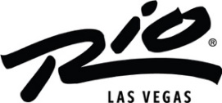

RIO LAS VEGAS UNVEILS STUNNING NEW POOL DESIGN INSPIRED BY THE VIBRANT SPIRIT OF RIO DE JANEIRO

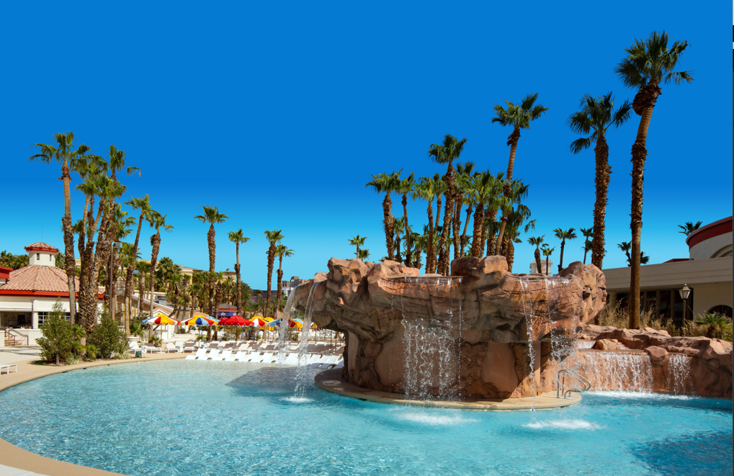
Link to photo here

LAS VEGAS (APR. 25, 2024) – Nestled in the heart of the Rio Hotel & Casino lies a vibrant oasis inspired by the beaches of Rio de Janeiro, Brazil. The new pool channels the essence of Ipanema and Copacabana, blending fun, eclecticism and midcentury charm. Drawing from the designs of Roberto Burle Marx, the pool features a colorful array of brand new umbrellas, bright yellow cabanas and an abundance of chaises. Amidst this vibrant ambiance lie the Nautius pool, Fish pool, Lagoon pool and Shell pool —each with its own distinct charm. The Lagoon pool, flanked by two hot tubs on each side, provides an enchanting experience. Guests basking in the warm hues poolside find themselves transported to a world where every moment celebrates the joyous rhythm of Rio.

New Pool Decks Experience
The revamped Pool Decks stand as central features in the guest experience, exuding a beachy, relaxed vibe that complements the hotel's interior style. Recently renovated with entirely new finishes and furnishings, the decks offer a refreshed atmosphere. The layout allows for flexible seating arrangements, accommodating individual preferences and special events. The main deck boasts a plethora of chaise lounges, umbrellas, daybeds and cabanas, providing ample relaxation space. Meanwhile, the adult deck, designed for guests aged 21 and above, offers a tranquil retreat with a selection of loungers, daybeds, cabanas and umbrellas, all brand new and exclusively tailored to adults seeking a tranquil environment.

Refreshments
At the recently refurbished Rio pool, guests are treated to a diverse range of dining experiences. Bar Sol offers a relaxed atmosphere coupled with stunning skyline views, where visitors can savor expertly crafted tropical cocktails that encapsulate the spirit of Rio. Similarly, Bar Aqua beckons guests to unwind amidst vibrant graffiti art, celebrating the lively energy of Rio de Janeiro against a picturesque backdrop. The culinary team is expanding and curating the poolside menu, emphasizing the use of fresh ingredients. Additionally, this year Rio is reintroducing the 32oz Double Wall Souvenir Cups available in four colors for guests to collect.

About the Rio Hotel & Casino Las Vegas
Located one block off the famed Las Vegas Strip on Flamingo Road, Rio Hotel & Casino Las Vegas features over 2,500 580 Sq. Ft. all-suite guest rooms, 220,000/sf of convention and meeting space, a 5-acre pool area, and a 150,000/sf casino with 40+ tables and 1000+ slot machines. Dreamscape’s plan for the resort’s future includes a property refresh, from dynamic new dining offerings to a variety of entertainment options. Dreamscape’s intent is to preserve the property’s architecture and honor its legacy. The property will remain open throughout the renovations.

# # #
Media Contacts
Alden Tseng | Sandra Esparza
Kirvin Doak Communications
RioLasVegasPR@KirvinDoak.com

